WIREFRAME DOCUMENT iNeuron page 1

WIREFRAME DOCUMENT

MUSHROOM CLASSIFICATION

Revision No – 1.1

Last Date of Revision – 12/09/2023

Author: Aishik Chatterjee

WIREFRAME DOCUMENT iNeuron page 2

**Document Version Control:**

|  |  |  |
| --- | --- | --- |
| **Date Issued** | **Version** | **Description** |
| 11/09/2023 | 1 | Web Interface |
| 12/09/2023 | 1.1 | Sample Cases |

WIREFRAME DOCUMENT iNeuron page 3

CONTENTS

|  |  |  |
| --- | --- | --- |
| Sr. No. | Description | Page No. |
|  | Document Version Control | 2 |
|  | Abstract | 4 |
| 1 | Web Interface | 5 |
| 1.1 | Home Page | 5 |
| 1.2 | How to use? | 6 |
| 1.3 | Results Page | 7 |
| 2 | Sample Cases | 8 |

WIREFRAME DOCUMENT iNeuron page 4

**Abstract**

Mushrooms have been consumed since earliest history. The word Mushroom is derived from the French word for Fungi and Mold. Now-a-days, Mushroom are popular valuable food because they are low in calories, carbohydrate, Fat, sodium, and cholesterol free. Besides this, Mushroom provides important nutrients, including selenium, potassium, riboflavin, niacin, Vitamin D, proteins, and fibre. All together with a long history as food source. Mushrooms are important for their healing capacity and properties in traditional medicine. It has reported beneficial effects for health and treatment of some disease. Many nutraceutical properties are described in Mushroom like cancer and antitumor attributes. Mushroom act as antibacterial, immune system enhancer and cholesterol lowering Agent. Additionally, they are important source of bio-active compounds. This work is a machine learning model that classifies mushrooms into 2 classes: Poisonous and Edible depending on the features of the mushroom. During this machine learning implementation, we are going to see which features are important to predict whether a mushroom is poisonous or edible.

WIREFRAME DOCUMENT iNeuron page 5

**1. Web Interface**

App Link: <https://aishik1.pythonanywhere.com/>

* 1. **Home Page**

When the user clicks on the app link given above, it will direct user to our home page which looks like below:

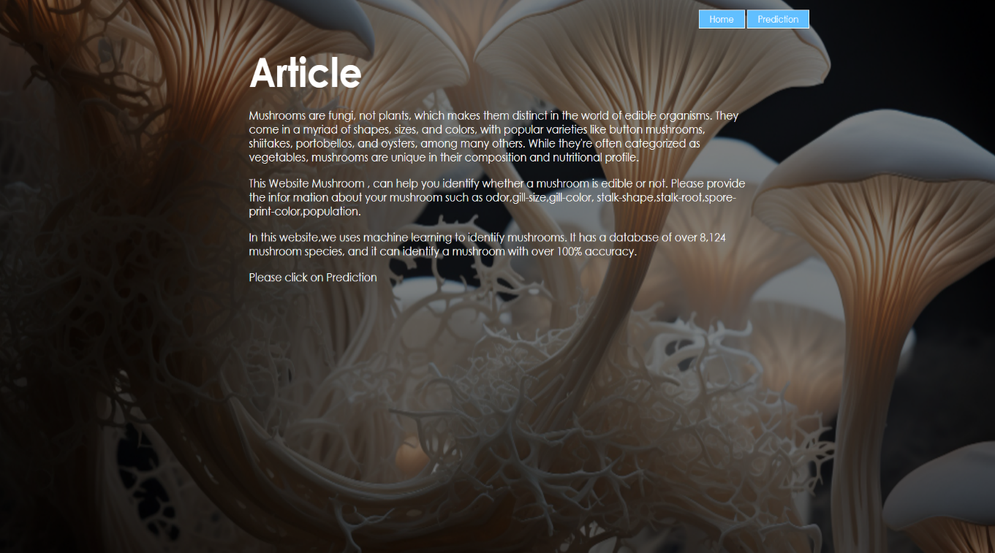

**Then click on prediction to check your mushroom .**

As you can see, there are total of 7 input fields (drop downs) you need to select based on the characteristics of the mushroom to find out if it’s edible or poisonous. There is a “Submit” button which redirect you the results page which will tell if the mushroom is poisonous or edible.

WIREFRAME DOCUMENT iNeuron page 6

* 1. How to use?

As you can see in the above picture you need to select the characteristics of the mushroom using the drop downs provided for each input fields.

Just select that particular options then submit 😊 .

If edible then is shows bottom of the the Mushroom is Edible else poisonous.